RMAN Enhancements
In this section, we will discuss the new features of Recovery Manager (RMAN) in Oracle 10g.
Automated Channel Failover for Backup and Restore
In Oracle 10g, when multiple channels are allocated for a backup and restore operation, and one of the channels fails during the operation, RMAN continues the job on the remaining channels. RMAN does not restart the backup or restore process for the failed channel. Such a problem is typical when the media manager encounters problems with one tape drive. RMAN reports a message in v$rman_output and in the output to the terminal or log file when it encounters such problems.
Automated File Creation During Recovery
This feature enhances RMAN recovery by automatically creating and recovering datafiles that have never been backed up.

In order to recover a data file that has never been backed up, you need the archive log files from the time of the data file creation until the time you wish to stop the recovery process, and a copy of the control file with the information regarding the data file.

Figure 12.5 Automated File Creation During Recovery
Simplified Backups to Disk
In previous releases of Oracle, RMAN had two separate commands to backup data files: BACKUP and COPY. The BACKUP command backed up the data file only to backup set, which is a proprietary format recognized by RMAN only. You must use RMAN to restore a data file from a backup set. The COPY command generated image copies, which are bit-by-bit copies of data files. You do not need RMAN to restore a database from an image copy.

The BACKUP DATABASE command can backup a whole database to backup sets without specifying each individual data file. However, there is no corresponding COPY DATABASE command. Therefore, you must run the REPORT SCHEMA command to determine the file names of the data files, and then you need to specify each data files in your COPY command.

RMAN> copy current controlfile to ‘dba/backup/grid/ctlfile.cpy’,
datafile 1 to ‘dba/backup/grid/df1.cp’y,
datafile 2 to ‘dba/backup/grid/df2.cp’y,
datafile 3 to ‘dba/backup/grid/df3.cp’y,
datafile 4 to ‘dba/backup/grid/df4.cp’y,
datafile 5 to ‘dba/backup/grid/df5.cp’y,
datafile 6 to ‘dba/backup/grid/df6.cp’y;

In Oracle 10g, the COPY command is abandoned in favor of an enhanced BACKUP command that enables you to specify where RMAN should create copies or backup sets. You can use the new BACKUP AS COPY command to copy an entire database or multiple tablespaces, data files, and archived logs.

Here is an example to backup an entire database as an image copy to the recovery area.

RMAN> backup as copy
tag “weekly_backup” database;
Proxy Copy Backup of Archivelogs
The proxy functionality was first introduced in Oracle8i Release 1 (8.1.5). A proxy copy is a special type of backup, in which RMAN turns over control of the data transfer to a media manager that supports this feature. The PROXY option of the BACKUP command specifies that a backup should be a proxy copy.

For each file that you attempt to back up using the BACKUP PROXY command, RMAN queries the media manager to determine whether it can perform a proxy copy. If the media manager cannot proxy copy the file, then RMAN uses conventional backup sets to perform the backup. An exception occurs when you use the PROXY ONLY option, which causes Oracle to issue an error message when it is unable to proxy copy.

Prior to Oracle 10g, you could RMAN to perform proxy backups of data files and data file copies. However, you could not perform proxy backup of archive log files or control file copies. You can now use RMAN to perform proxy backups of archive log files. You can use the rc_proxy_archivelog dictionary view to determine the proxy backups recorded in the catalog.

RMAN> backup device type sbt proxy only
2> archivelog from logseq 35 thread 1;
Incrementally Updated Backups
In Oracle 10g, you can apply incremental backups to data file image copy backups to roll them forward to a specified point in time. This new feature provides the following benefits:
- By periodically updating image copies of data files with incremental backups, the updated image copy of the data file is moved forward to a more recent state (with more current SCN). This could potentially result in reduced recovery time.
- Avoids performing a full image copy after incremental backups.
Figure 12.6 Incrementally Updated Backups
Example
The following statement rolls forward an image copy of data file /dba/backup/grid/data01.imgcopy:

RMAN> recover datafilecopy ‘/dba/backup/grid/data15.imgcopy’;

Or, you can issue this command to perform the same operation:

RMAN> RECOVERY COPY OF DATAFILE 15;
Simplified Recovery Through Resetlogs
After you perform an incomplete (Point-in-time) recovery, you need to open the database with the RESETLOGS option:

SQL> alter database open resetlogs;

The RESETLOGS operation creates a new incarnation of the database and resets the logs. Prior to Oracle 10g, the newly generated redo log files could not be used with the backups taken in the past. Therefore, it was important to take an immediate backup, since all previous backups became invalid. In addition, if you used the RMAN catalog for future backups, you needed to issue the following command to make the RMAN catalog aware of the new incarnation of the database.

RMAN> reset database;

In Oracle 10g, you no longer have to back up your database following an incomplete recovery and OPEN RESETLOGS operations.

This new feature is also applicable for the following two scenarios:
- Performing a recovery using a backup control file and opening the database with the RESETLOGS operation.
- Reinstantiation of the old primary database following a failover (see the Flashback Reinstantiation section for details).
Benefits of Simplified Recovery Through Resetlogs
The Simplified Recovery Through Resetlogs feature provides the following benefits:
- There is no need to perform a full backup after an incomplete recovery.
- There is no need to recreate a new standby database after a failover operation.
- There is no need to change any backup scripts, as there are no changes in the recovery commands to take advantage of this functionality.
- You can take incremental backups based on full backups of a previous incarnation when you use RMAN.
- Block media recovery can restore backups from parent incarnation backups and recover the corrupted blocks through a RESETLOGS operation.
How does it work?
You may wonder how can you use the newly generated logs with an earlier incarnation of the database. Oracle 10g introduces a new format specification for archived log files. This new format avoids overwriting archived redo log files with the same sequence number across incarnations.

SQL> show parameter log_archive_format
NAME TYPE VALUE
---------------------------- ----------- ----------------
log_archive_format string %t_%s_%r.dbf

The format specification is %r and represents the resetlogs id. It is included in the default format for the log_archive_format initialization parameter. It will ensure that a unique name is constructed for the archived redo log file during RMAN restore and SQL*plus auto recovery mode.

During the RESETLOGS operation, the information in v$log_history and v$offline_range records are no longer cleared. In addition, two new columns have been added to indicate the incarnation the records belong to: resetlogs_change# and resetlogs_time.
Example:
SQL> select recid, thread#, sequence#, resetlogs_change#,resetlogs_time
2 from v$log_history
3 where rownum < 20;

RECID THREAD# SEQUENCE# RESETLOGS_CHANGE# RESETLOGS_TIME
---------- ---------- ---------- ----------------- --------------------
1 1 1 1 Aug 12 2003 18:48:54
2 1 2 1 Aug 12 2003 18:48:54
3 1 3 1 Aug 12 2003 18:48:54
4 1 4 1 Aug 12 2003 18:48:54
5 1 5 1 Aug 12 2003 18:48:54
6 1 6 1 Aug 12 2003 18:48:54
7 1 7 1 Aug 12 2003 18:48:54
8 1 8 1 Aug 12 2003 18:48:54
9 1 9 1 Aug 12 2003 18:48:54
10 1 10 1 Aug 12 2003 18:48:54
11 1 11 1 Aug 12 2003 18:48:54
12 1 12 1 Aug 12 2003 18:48:54
13 1 13 1 Aug 12 2003 18:48:54
14 1 14 1 Aug 12 2003 18:48:54
15 1 15 1 Aug 12 2003 18:48:54
16 1 16 1 Aug 12 2003 18:48:54
17 1 17 1 Aug 12 2003 18:48:54
18 1 18 1 Aug 12 2003 18:48:54
19 1 19 1 Aug 12 2003 18:48:54

19 rows selected.
Full Database Begin Backup Command
Oracle 10g allows all of the data files in the database to be placed in online backup mode using a single command:

SQL> ALTER DATABASE BEGIN BACKUP;

You no longer need to place each tablespace in online backup mode individually:

SQL> ALTER TABLESPACE user BEGIN BACKUP;
SQL> ALTER TABLESPACE example BEGIN BACKUP;

The ALTER DATABASE BEGIN BACKUP command places all data files in the database in online backup mode. The database must be in mounted or open mode when you issue this command.
Example 1: Issue BEGIN BACKUP command when data files belonging to a tablespace are in READ-ONLY mode
SQL> alter tablespace users read only;

Tablespace altered.

SQL> alter tablespace users begin backup;
alter tablespace users begin backup
*
ERROR at line 1:
ORA-01642: begin backup not needed for read only tablespace 'USERS'

SQL> alter database begin backup;

Database altered.
Example 2: Issue BEGIN BACKUP command when data files belonging to a tablespace are in READ-ONLY mode
SQL> alter tablespace example offline;

Tablespace altered.

SQL> alter tablespace example begin backup;
alter tablespace example begin backup
*
ERROR at line 1:
ORA-01128: cannot start online backup - file 5 is offline
ORA-01110: data file 5: 'C:\ORACLE\ORADATA\GRID\EXAMPLE01.DBF'

SQL> alter database begin backup;

Database altered.

The two examples above demonstrate that when you issue the ALTER DATABASE BEGIN BACKP command, any read-only and offline data files are simply skipped, and processing continues.
Changes to the ALTER DATABASE END BACKUP command
You can run the ALTER DATABASE END BACKUP command when you have multiple tablespaces still in backup mode. You can issue the statement to take all data files currently in backup mode out of backup mode. However, you can use this statement only when the database is mounted, and not open in Oracle9i. If the database is open, you can only use ALTER TABLESPACE ... END BACKUP or ALTER DATABASE DATAFILE ... END BACKUP for each affected tablespace or datafile.

In Oracle 10g, you can issue the ALTER DATABASE END BACKUP command when the database is open.

If you issue the command while one of the data files is offline or in read-only mode, a warning message will return:

SQL> alter database end backup;
alter database end backup
*
ERROR at line 1:
ORA-01260: warning: END BACKUP succeeded but some files found not to be in backup mode
Change-Aware Incremental Backups
In previous releases of the Oracle database, RMAN had to examine every block in the data file to determine which blocks had been changed when performing an incremental backup. The time to perform an incremental backup was proportional to the size of the data files. Therefore, performing an incremental backup on a very large database could take some time, even if only a few blocks were changed.

In Oracle 10g, you can create a block change tracking file that records the blocks modified since the last backup. RMAN uses the tracking file to determine which blocks to include in the incremental backup. RMAN no longer needs to examine the entire data file. The time to perform an incremental backup is now proportional to the amount of content modified since the last backup.

Here are the steps RMAN will perform to do an incremental backup:
- Read the Block Change Tracking File to determine which blocks in the data file need to be read.
- Scan only the changed blocks (See Figure 12.1) in the data file and then back them up.
Figure 12.7 Incremental Backup using Block Change Tracking File
How big is the Block Change Tracking File?
The size of the block change tracking file is proportional to:
- The database size in bytes: the block change tracking file contains data representing every data file block in the database. The data is approximately 1/250000 of the total size of the database.
- The number of enabled threads: In a Real Application Cluster (RAC) environment, the instances update different areas of the tracking file without any locking or inter-node block swapping. You enable block change tracking for the entire database and not for individual instances.
- The number of old backups: The block change tracking file keeps a record of all changes between previous backups, in addition to the modification since the last backup. It retains the change history for a maximum of eight backups.
The size of the file is calculated by the following formula:

Size of the Block Change Tracking File =

( (Threads*2) + number of old backups ) * database size in bytes
250,000

The minimum size for the block change tracking file is 10 MB. Using this formula, a 2 TB database with only one thread and having five backups in the RMAN repository will require a block change tracking file of 59 MB.
Enabling, Disabling and Monitoring Block Change Tracking
By default, Oracle will not record block change information. To enable this feature, you need to issue the following command:

SQL> alter database enable block change tracking;

To disable this feature, you issue this command:

SQL> alter database disable block change tracking;

To monitor the status of block change tracking, you type:

SQL> select file, status, bytes
2 from v$block_change_tracking;

STATUS FILE BYTES
----------- ---------------------------- ---------------
ENABLED /dba/backup/01_mf_yzmrr7.chg 10,000,000
Automated Disk-Based Backup and Recovery
Prior to Oracle 10g, disk files that were created by the RMAN utility or ARCH process had no knowledge of one another. Furthermore, they were not aware of the sizes of the file system on which they created files. Database administrators needed to routinely clean up the old archive logs or old RMAN files.

It is better to have a unified disk storage location where you can manage all recovery-related files. Now you can achieve this in Oracle 10g by specifying a Recovery Area.
Recovery Area
The recovery area is a unified disk storage location for all recovery-related files and activities in an Oracle Database. Those files include:
- Control file
- Online redo log files
- Archived log files
- Flashback logs
- Control file autobackups
- Data file copies
- RMAN files
Setting up a Recovery Area
The recovery area is defined by setting two initialization parameters. These two parameters can be dynamically altered or disabled.
- The db_recovery_file_dest_size sets the disk limit, expressed in bytes
- The db_recovery_file_dest sets the location for the recovery area
Enabling a Recovery Area
This statement sets the disk limit for recovery area to 100 GB:

SQL> ALTER SYSTEM
SET DB_RECOVERY_FILE_DEST_SIZE = 100G

This statement sets the recovery area destination:

SQL> ALTER SYSTEM
SET DB_RECOVERY_FILE_DEST = ‘/dba/backup/’;
Alter a Recovery Area
This statement alters the size of the recovery area:

SQL> ALTER SYSTEM
SET DB_RECOVERY_FILE_DEST_SIZE = 200G;
Disabling a Recovery Area
This statement disables a recovery area:

SQL> ALTER SYSTEM
SET DB_RECOVERY_FILE_DEST = ‘ ’;
Recovery Area Space Management
When the recovery area is less than 90% full, Oracle does not delete eligible files immediately, to minimize the need to restore recent files from tape during recovery. The recovery area can thus serve as a kind of cache for tape.

Once the recovery area is 90% full, Oracle will issue a warning to users. The Oracle database server and RMAN will continue to create files in the recovery area until 100% of the disk limit is reached.

Once the recovery area is 100% full, the RMAN retention policy is used to indicate what files will be deleted in order to make space for newer files.

The db_flashback_retention_target parameter specifies how long Oracle will keep the flashback logs in the flashback recovery area. However, flashback logs won't be deleted, even if they exceed the duration specified by the flashback retention period, unless more space is needed in the recovery area for other files.
New RMAN command for Recovery Area
RMAN> BACKUP RECOVERY AREA;
RMAN> BACKUP RECOVERY FILES;
New Recovery Area Dictionary View
Oracle 10g has a new dynamic performance view for monitoring the recovery area:

SQL> desc v$recovery_file_dest
Name Null? Type
---------------------------------------- -------- -----------
NAME VARCHAR2(513)
SPACE_LIMIT NUMBER
SPACE_USED NUMBER
SPACE_RECLAIMABLE NUMBER
NUMBER_OF_FILES NUMBER

Column Description:
- NAME: Recovery area name, indicating location string.
- SPACE_LIMIT: used space by recovery area files in bytes
- SPACE_RECLAIMABILE: amount of space that can be created by deleting obsolete, redundant, and other low priority files through the space management algorithm.
- NUMBER_OF_FILE: number of files
Example:

SQL> select * from v$recovery_file_dest;

NAME SPACE_LIMIT SPACE_USED SPACE_RECLAIMABLE NUMBER_OF_FILES
------------ ------------- ------------ ----------------- ----------------
/dba/backup 2147483648 458219520 0 49
RMAN Database Dropping and Deregistration
Oracle 10g allows a database to be dropped and its entry removed from the RMAN catalog.

The following statement drops the entire database and removes the database files:

RMAN> drop database;

The statement below drops the entire database, removes the database files, and deletes all backup copies of the database and the archive log files:

RMAN> drop database including backups;

The two statements above drop the database and delete the database files. However, they do not unregister the database from the RMAN catalog. The following statement will remove the database information from the RMAN catalog:

RMAN> unregister database grid;
Automated TSPITR Instantiation
In previous Oracle releases, you could use RMAN to perform tablespace point in time recovery (TSPITR). However, you needed to create an auxiliary instance manually.

In Oracle 10g, when you perform tablespace point in time recovery, RMAN creates an auxiliary instance automatically on the same target database server. RMAN removes the auxiliary instance after you complete the tablespace recovery.

RMAN creates the data files required by the auxiliary instance as specified by set newname, configure auxname, and db_file_name_convert. RMAN removes these files when the recovery tasks are completed.
Simplified Recovery Manager Cataloging of Backup Files
Every time RMAN backs up a database into backup sets and backup pieces, it updates the RMAN catalog to reflect the backup information. If a user removes, relocates, or renames a backup piece, you cannot make corresponding changes to the RMAN catalog in the earlier versions of the oracle database.

However, in Oracle 10g, you can use the CATALOG command to enter the new filename or location for backup pieces in the RMAN catalog. In addition, you can use the CATALOG command to enter user-managed data file copies. The UNCATALOG command is used to remove the backup pieces from the catalog.
Example 1: To catalog a backup piece
RMAN> catalog backuppiece
2> ‘/dba/backup/rman/data01.bkp’;
Example 2: To catalog a user-managed data file copy
RMAN> catalog backup
2> ‘/dba/backup/grid/data01.dbf’;
Example 3: To uncatalog a backup piece
RMAN> change backupiece
2> ‘/dba/backup/grid/data01.bkp’ uncatalog;
RMAN and the new EM (Enterprise Manager)
The new Enterprise Manger in Oracle Database 10g makes the backup a lot easier to work with the new features.

Here is an EM screenshot of configuring Backup Settings:

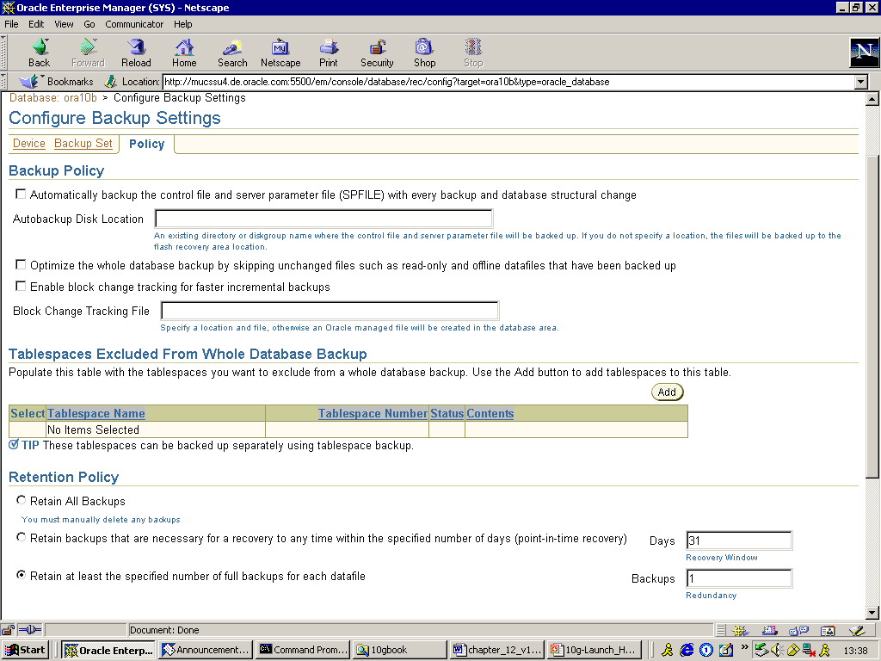
Figure. 12.8 Configuring Backup Settings in Enterprise Manager

Here is another example of setting up a backup strategy using EM:

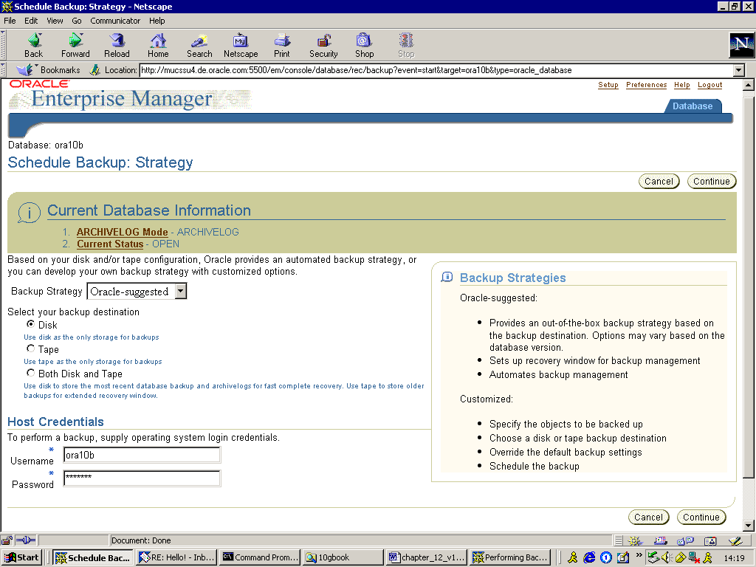
Figure 12.9 Another Backup Strategy Using Enterprise Manager

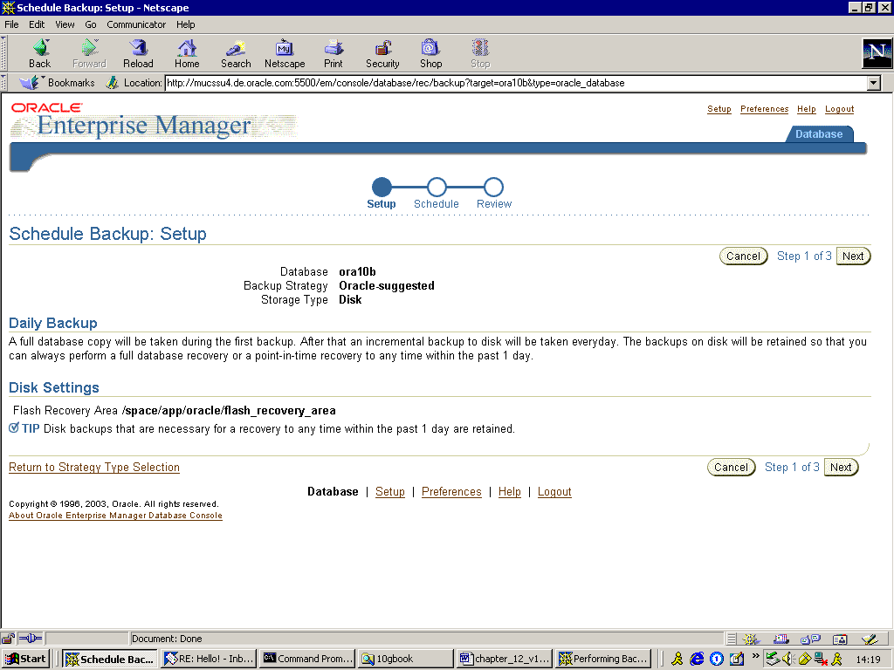
Figure 12.10 Backup Set-up Using Enterprise Manager
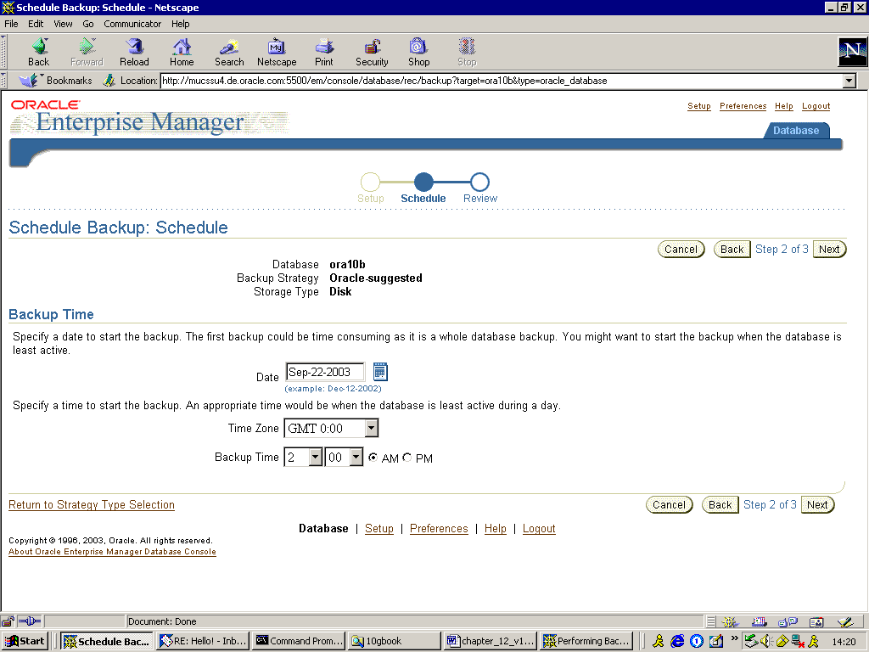
Figure 12.11 Backup Set-up Using Enterprise Manager

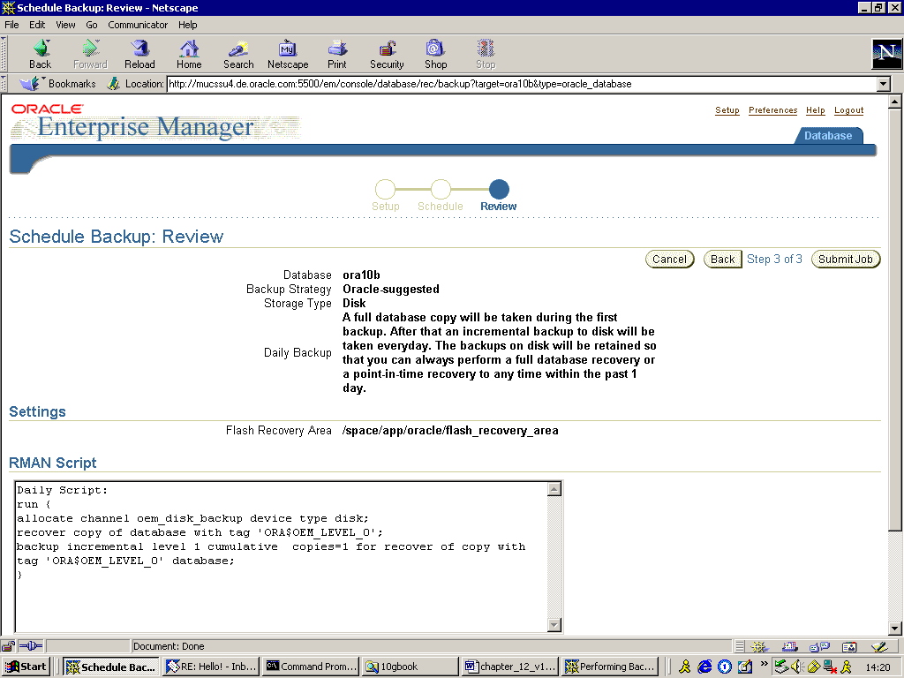
Figure 12.12 Backup Set-up Using Enterprise Manager
Conclusion
In this chapter we have examined the new and improved features related to backup and recovery in Oracle 10g. Specifically, we have looked at two areas: extended flashback functions and enhanced RMAN utility. The new features simplify database backup and deliver fast and flexible data recovery.

The above is an excerpt from the bestselling Oracle10g book Oracle Database 10g New Features by Mike Ault, Madhu Tumma and Daniel Liu, published by Rampant TechPress.

Mike Ault, one of the world's top Oracle experts, has finally consented to release his complete collection of more than 450 Oracle scripts, covering every possible area of Oracle administration and management.
This is the definitive collection of Oracle monitoring and tuning scripts, and it would take thousands of hours to re-create this vast arsenal of scripts from scratch.
Mike has priced his collection of 465 scripts at $39.95, less than a dime per script. You can download them immediately at this link:
http://www.rampant-books.com/download_adv_mon_tuning.htm

